**ITCS451, Semester 1/2022**

**Bayesian Network Project**

**Group members**

|  |  |  |  |
| --- | --- | --- | --- |
| **No.** | **Student ID** | **Student name** | **Section** |
|  | 6388014 | Waris Damkhum | 1 |
|  | 6388022 | Pattanan Korkiattrakool | 1 |
|  | 6388094 | Vipavee Ngamyingsurat | 1 |
|  | 6388097 | Thanakij Pinyoboon | 1 |

1. Description of the problem you are modeling.

* Cancer is a condition in which the body's cells proliferate unchecked. Lung cancer is the name for cancer that first appears in the lungs. In addition to lymph nodes and other body organs including the brain, lung cancer can also start in the lungs. Lung cancer can potentially spread from other organs. Metastases are cancer cells that have spread from one organ to another. Small cell and non-small cell lung tumors are the two primary subtypes that are typically recognized (including adenocarcinoma and squamous cell carcinoma). These distinct forms of lung cancer develop differently and respond to various therapies. Compared to small cell lung cancer, non-small cell lung cancer is more prevalent. This dataset is the effectiveness of cancer prediction system helps the people to know their cancer risk with low cost and it also helps the people to take the appropriate decision based on their cancer risk status.

1. Did you use real data?

🞏 Yes 🞏 No

If yes, describe your data in the following table.

|  |  |
| --- | --- |
| **Source of data** | https://www.kaggle.com/datasets/mysarahmadbhat/lung-cancer |
| **Type of data** | raw data  published statistics |
| **Modification to the data (If any)** | Yes, modified. We have merged all ages into ranges from source data. |

1. Bayes net description.
   1. Bayes net description

* This model will show all possible symptoms of lung cancer by calculating all environments that cause lung cancer such as alcohol consumption, smoking, chest pain, age, gender, and furthermore.
  1. 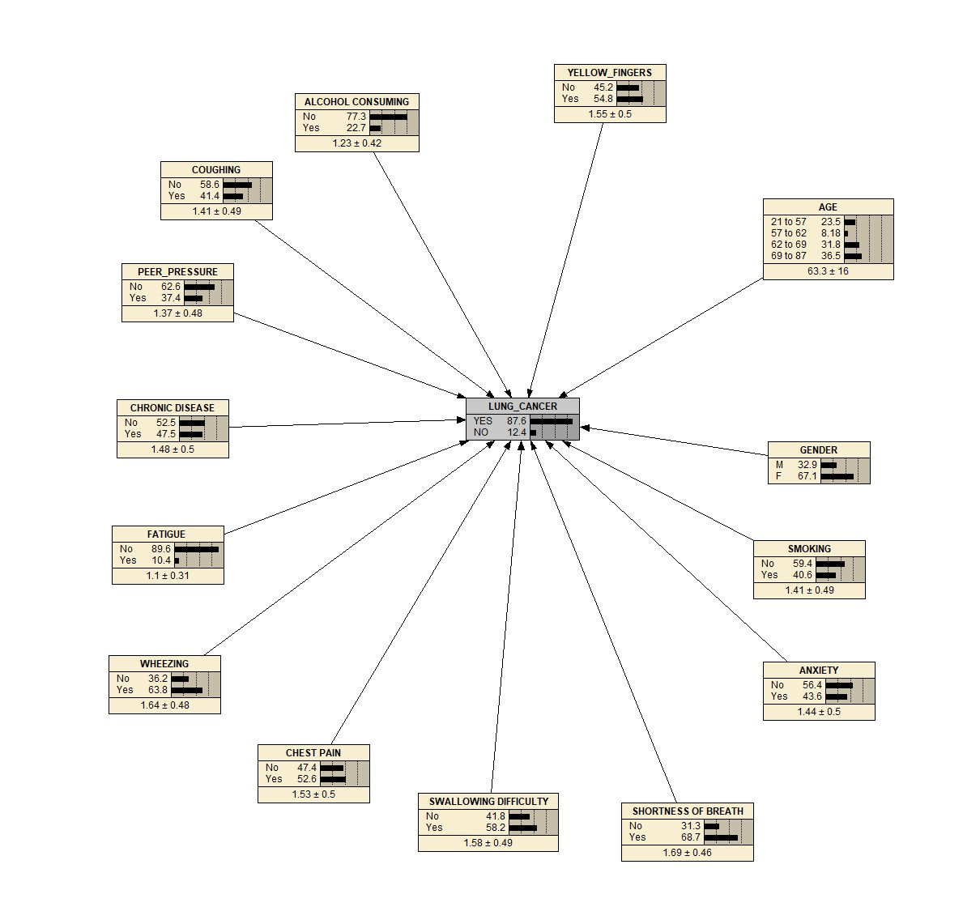Bayes net screenshot

1. Explanation of your network

|  |  |  |
| --- | --- | --- |
| **No.** | **Node Name** | **Node Description** |
|  | Lung_cancer | Have this specific symptom  Yes = 2, No = 1 |
|  | Fatigue | Have this specific symptom  Yes = 2, No = 1 |
|  | Age | In range of:  21 to 57 years old  57 to 62 years old  62 to 69 years old  69 to 87 years old |
|  | Wheezing | Have this specific symptom  Yes = 2, No = 1 |
|  | Alcohol Consuming | Have this specific symptom  Yes = 2, No = 1 |
|  | Coughing | Have this specific symptom  Yes = 2, No = 1 |
|  | Chronic Disease | Have this specific symptom  Yes = 2, No = 1 |
|  | Peer_Pressure | Have this specific symptom  Yes = 2, No = 1 |
|  | Anxiety | Have this specific symptom  Yes = 2, No = 1 |
|  | Yellow_Fingers | Have this specific symptom  Yes = 2, No = 1 |
|  | Smoking | Have this specific symptom  Yes = 2, No = 1 |
|  | Gender | M(male), F(female) |
|  | Shortness of breath | Have this specific symptom  Yes = 2, No = 1 |
|  | Swallowing Difficulty | Have this specific symptom  Yes = 2, No = 1 |
|  | Chest Pain | Have this specific symptom  Yes = 2, No = 1 |

1. Two examples of inference: Enter some evidence and show the updated probabilities of the main hypothesis node(s). Explain what each example is showing.
   1. Example1

* If the female subject had lung cancer between the ages of 69 to 87 with a yellow finger, they had always smoked, had shortness of breath, had chest pain, and had wheezing. Patients, however, do not experience anxiety, difficulty swallowing, fatigue, chronic disease, peer pressure, coughing, or alcohol consumption. The subject will have 76.7% lung cancer.

* 1. Example2
* If the male subject had lung cancer between the ages of 57 to 62, had always smoked, had difficulty swallowing, had shortness of breath, had fatigue, had a chronic disease, and had wheezing, Patients, however, do not experience anxiety, chest pain, peer pressure, coughing, a yellow finger, or alcohol consumption. The subject will have 53.4% lung cancer.

